Ms. Frazier’s Classroom PBIS Matrix
 | 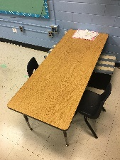  Ms. Frazier’s or Mrs. Giera’s Tables  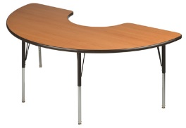 | 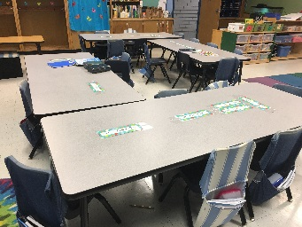  My Table | Carpet  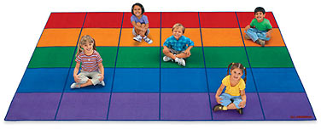
Respectful | 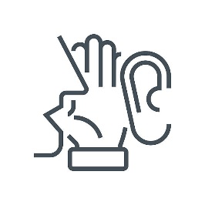  Listening ears.  Whisper.  Raise your hand. | Raise your hand.  No interrupting. | Raise your hand.  Hands and feet to yourself.
Responsible | 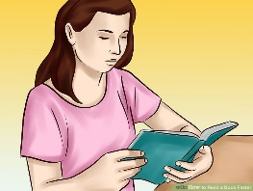  Read your book.  Follow directions. | Do your work!  Looking at the board.  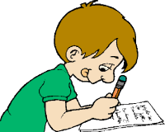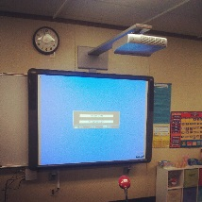 | 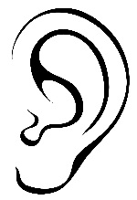  Listen to the teacher.  Turn and talk: Use inside voices.
Self-Control | Feet on the floor.  Sitting down. | No playing.  Feet on the floor.  Hands are still. | 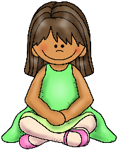  No playing.  Criss-cross applesauce.

