Instructional Access Form for Students
School: Henderson Mill Elementary School
Teacher: Ms. H. Frazier
The main platforms for Virtual Learning will be Google Classroom and Zoom. Google Classroom will be used for daily communication of learning assignments and teacher/student feedback. Zoom will be used for LIVE learning sessions or small group meetings. Below you will find additional resources that students will use. Please refer to this page for passwords.
Virtual Learning Technical Support Request Link - DCSD Technical Support
Help Desk 678-676-1188
Note: Technical support will be available through the teacher (Hannah_m_frazier@dekalbschoolsga.org) or school technology instructor, Abigail Roberts (Abigail_Roberts@dekalbschoolsga.org)
Platform: Raz-Kids  Link: https://www.raz-kids.com/  Access Credentials: Teacher username: hfrazier2 password: turtle  Platform: Google Classroom  Access Credentials: a5hj3un (class code)  Platform: 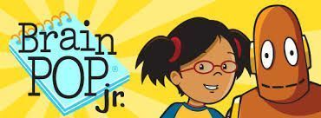 BrainPopJr.  Link: https://jr.brainpop.com/  Access Credentials: Username: henl215  Password: dekalb  Platform: Freckle  Link: https://student.freckle.com/#/login  Access Credentials: 4GYWNJ (class code)  Platform: Epic!  Link: www.getepic.com/students  Access Credentials: spe0952 (class code) | Platform: 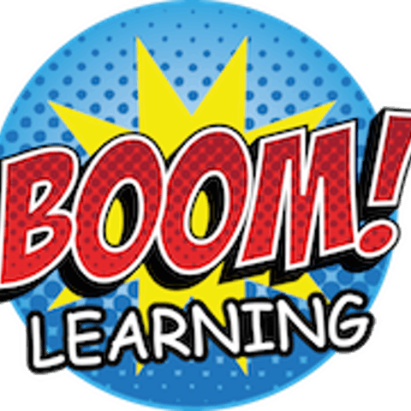 Boom! Cards  Link: https://wow.boomlearning.com/classroom/hanna-oedam/73rmqs  Access Credentials: *Usernames and passwords are individual, and will be sent to parents.  Platform: 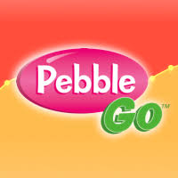PebbleGo  Link: https://site.pebblego.com/login/  Access Credentials: Username: henl215  Password: dekalb  Platform: Class Dojo  Link: https://www.classdojo.com/invite/?c=CVZ3MSN  Platform: 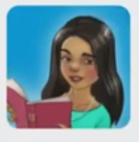 Imagine Learning  Access through DCSD Launchpad and student number and password.

*Please note that some of these resources are free apps you can download onto your phone or tablet.

